Dominion Online User Guide

March 2018

Version 1.1

*UMUC*

**Document Revisions**

|  |  |  |
| --- | --- | --- |
| **Date** | **Version Number** | **Document Changes** |
| 03/27/2018 | 1.0 | Initial Draft |
| 05/05/2018 | 1.1 | Updated Logging in and Account Creation Section |
|  |  |  |
|  |  |  |
|  |  |  |
|  |  |  |
|  |  |  |
|  |  |  |
|  |  |  |

**Table of Contents**

1 Introduction 4

1.1 Scope and Purpose 4

1.2 Process Overview 4

2 Logging in and Account Creation 5

2.1 Account Creation 5

2.2 Logging In 6

2.3 Starting a Game 6

2.4 Playing a Game 7

2.5 Match History 7

3 Card Types 9

3.1 Victory Cards 9

3.2 Curse Cards 10

3.3 Treasure Cards 10

3.4 Action Cards 11

3.4.1 Attack Action Cards 11

3.5 Reaction Cards 12

4 The Player Turn 13

4.1 Action Phase 13

4.2 Buy Phase 13

4.3 Cleanup Phase 13

# Introduction

## Scope and Purpose

Our goal for this project is to create an online, multiplayer version of the popular board/deck building game “Dominion”. It was created by Donald X. Vaccarino and is published by Rio Grande Games. Designed for 2 players, a typical match may take between 10-30 minutes.

This user guide strives to guide new players through the user interface, rules of the game, and common win conditions.

## Process Overview

Players will log into the game website at http://test-no.de, where they can register an account or log in to an existing account. The account will allow players to track a history of past games, other players they have gamed with, and a record of victories.

The backend software tracks when enough players are logged in to begin a new game. When this occurs, the system notifies the selected group that their game is about to begin and prepares a player view for each connected to the shared game board.

At the site’s main game screen players will see a view consisting of the Dominion game board, oriented such that their side is facing the bottom of the screen. Each player takes their turn in order, while being able to manage and view other aspects of the deck and board state.

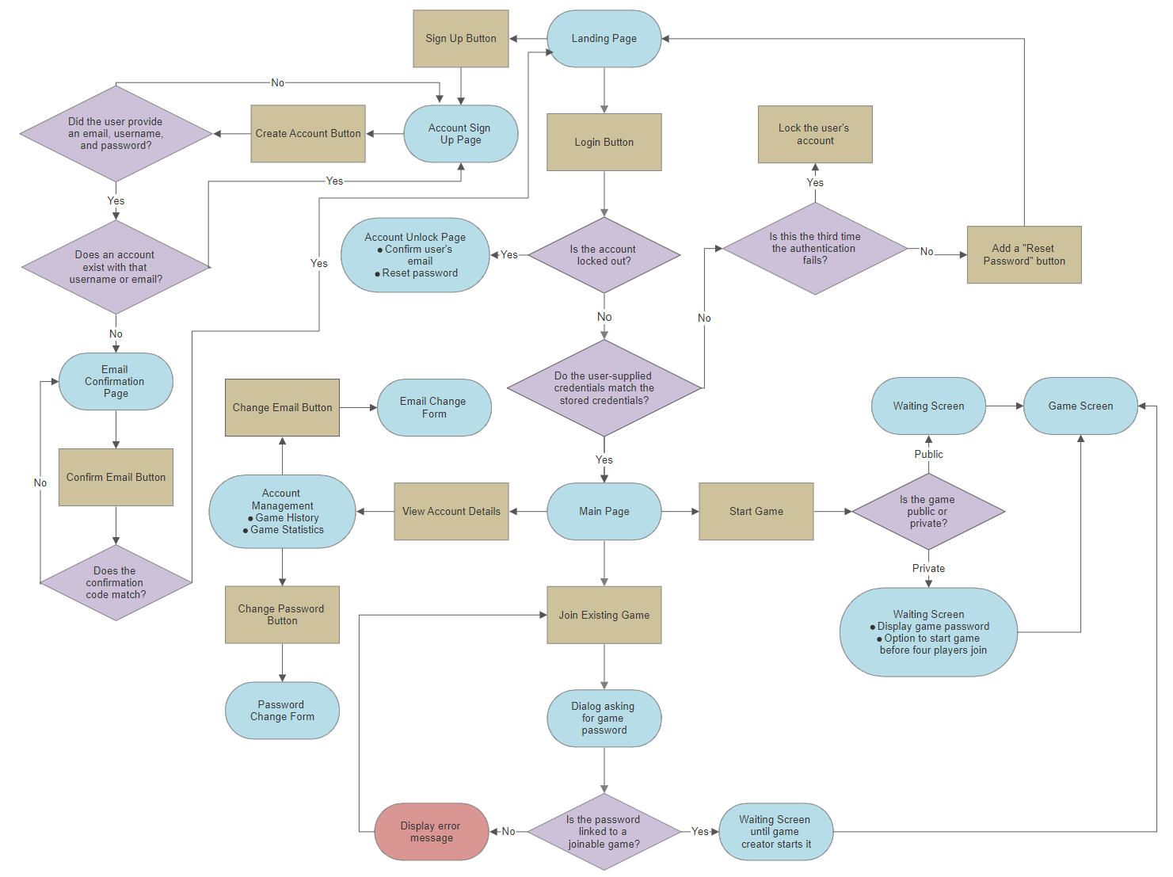

# Logging in and Account Creation

This section will describe the login process, attributes of a player account, and required information.

## Account Creation

If a user wants to play the game, they will first have to create an account through the sign up page.

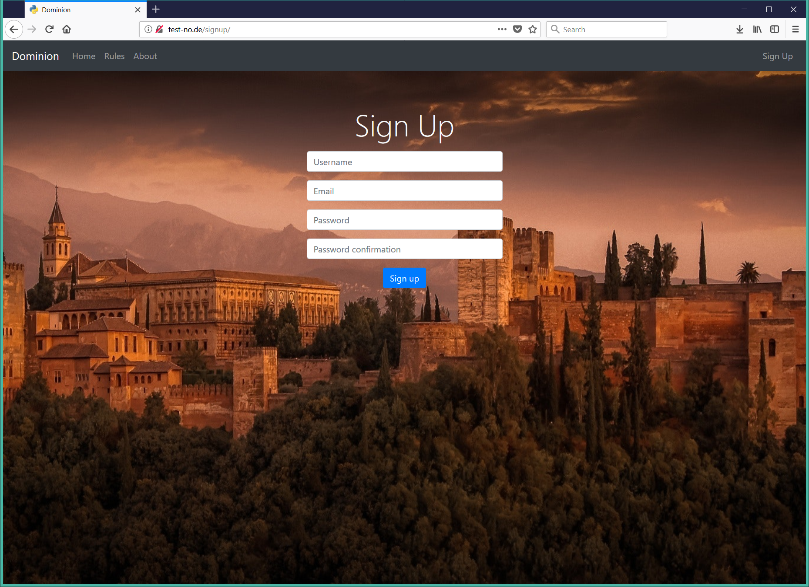

|  |  |
| --- | --- |
| **Indicator** | **Definition** |
| **Username** | User inputs their personal username that uniquely identifies them. |
| **Email** | The email associated with the account for account recovery purposes. |
| **Password** | The password associated with the username above, chose during sign up. Must be at least 8 characters long and include one number. |

## Logging In

Players provide username/email address and a password, which is checked against the corresponding back end database entry.

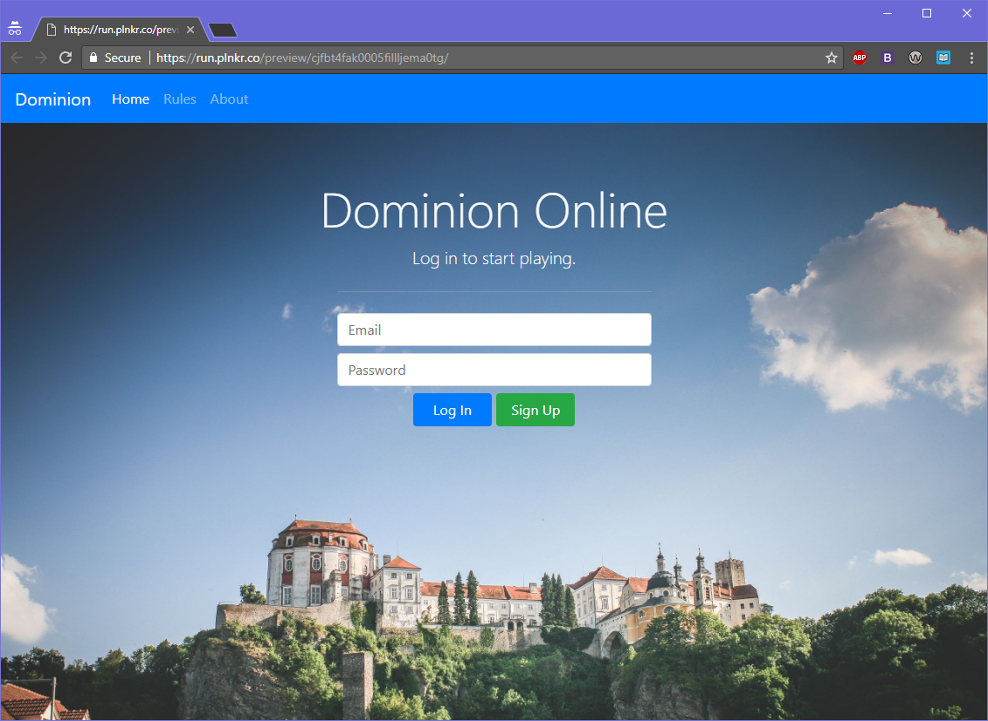

|  |  |
| --- | --- |
| **Indicator** | **Definition** |
| **Username** | User inputs their personal username that uniquely identifies them. |
| **Password** | The password associated with the username above, chose during sign up. Must be at least 8 characters long and include one number. |

## Starting a Game

Players are presented with the main screen once they login with a button to join a game and options to manage their account.

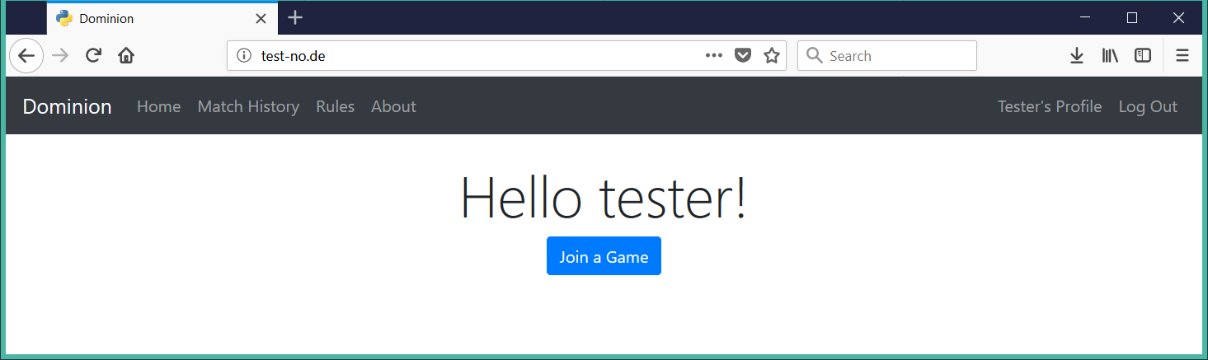

## Playing a Game

Once a player begins a game, they will be sent to a waiting screen and after an opponent is found, they will be taken to the game page. This page is updated throughout the game.

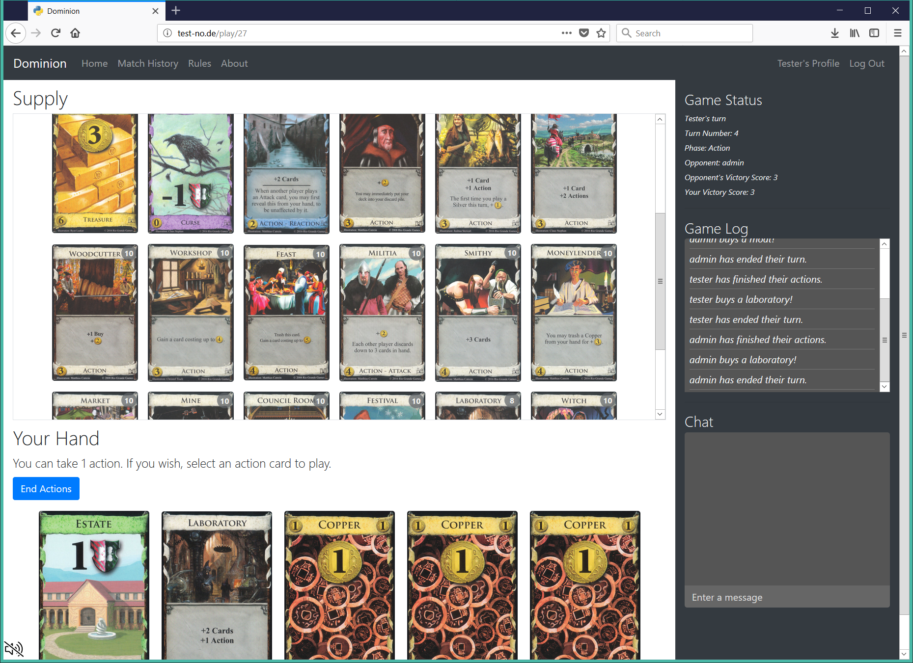

## Match History

This page contains a history of all of past matches played.

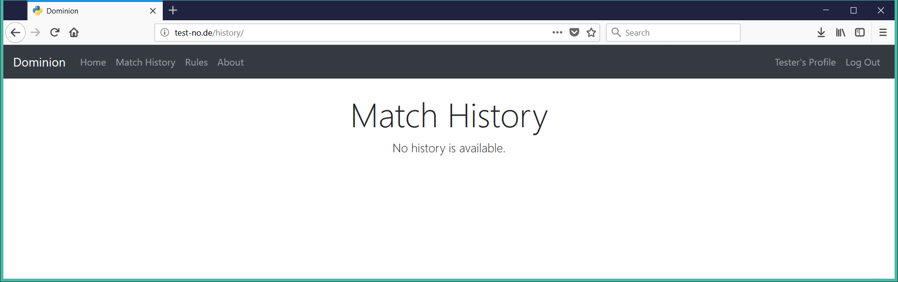

# Card Types

This section will describe the different types of cards. Each card, no matter the type, has a few elements in common as shown by the image below. Some cards can be multiple types and so combine multiple elements of the below sections.

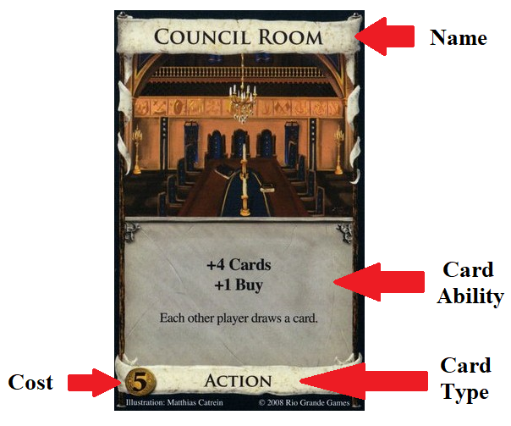

## Victory Cards

Provide victory points, but are otherwise unused during the game. As indicated by the card below, a Duchy would be worth three victory points at the end of the game.

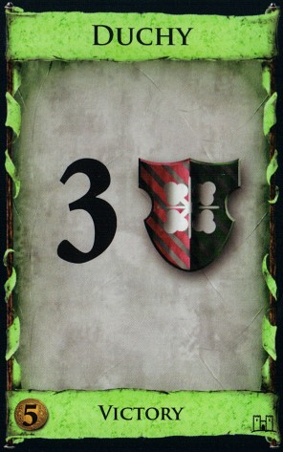

## Curse Cards

Like Victory cards, but have a negative point value! Certain Attack Action cards give these to the other players. There is only one curse card.

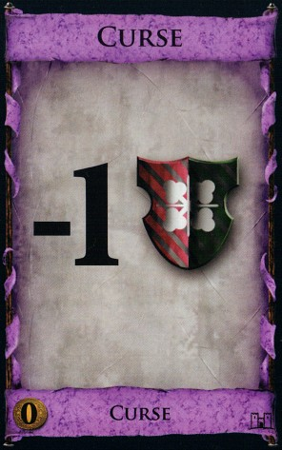

## Treasure Cards

Generate Coins, which are used to buy other cards during the Buy phase. The card below is a Silver which is worth two Coins.

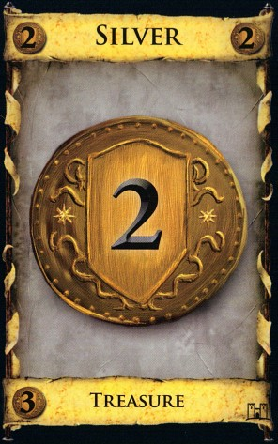

## Action Cards

Generate effects during the player’s Action phase. For example, the Village card gives the player two additional Actions and lets them draw a card.

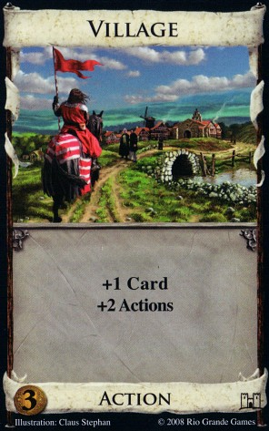

## Attack Action Cards

The effects these action cards generate affect the other players negatively. For example, the Militia card gives the current player two Coins and makes the other players discard down to three cards .

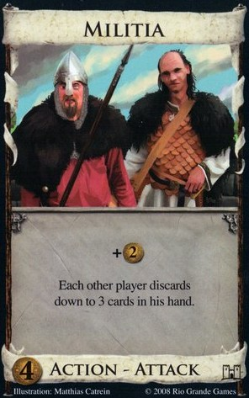

## Reaction Cards

Generate effects based on the current player’s or other player’s actions. When a certain trigger happens, the Reaction card can be revealed and the effect can be used. If a Reaction card has another type, the reaction effect is put below the horizontal line. For example, the Moat card’s reaction effect allows the player to avoid the effects of other player’s Attack cards.

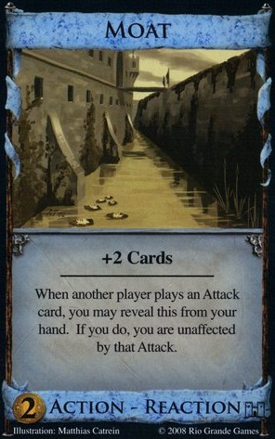

# The Player Turn

This section describes the phases of the player turn.

## Action Phase

During their turn, a player can play one Action card for each Action available to them. The player starts with one Action available to use. The instructions on the card will dictate what happens next. Actions can have a variety of effects, and there may be opportunities to play more Action cards in the same turn.

## Buy Phase

A player can play Treasure cards from their hand to generate Coins during this phase. For each Buy action they have, a player can use the Coins they have generated to purchase a card from the Supply. The total cost of the cards bought can be no more than the amount of Coins they have. If a player has no Coins they may still buy Cards with a Coin cost of zero (0).   
Purchased cards are added to the player’s discard pile, and will be shuffled back into their deck later on when the current Deck runs out.

## Cleanup Phase

The Player’s existing Hand goes into their Discard pile. The player draws five new cards from their Deck. If there are not enough cards in the Deck to draw five, the Discard pile is shuffled and then used as the Deck. Note that any remaining Actions, Buys and Coins do not carry over and are lost!